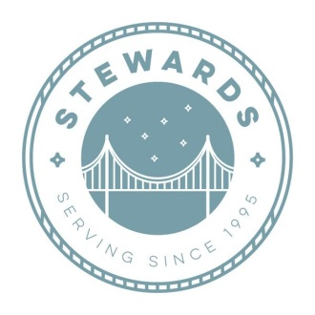
Stewards
Direct Deposit Agreement Form
Authorization Agreement
I hereby authorize Stewards to initiate automatic deposits to my account at the financial institution named below.

Further, I agree not to hold Stewards responsible for any delay or loss of funds due to incorrect or incomplete information supplied by me or by my financial institution in depositing funds to my account.

This agreement will remain in effect until Stewards receives a written notice of cancellation from me or my financial institution, or until I submit a new direct deposit form.

Account Information
Name of Financial Institution: _______________________________

Routing Number: _______________________________

Account Number: _______________________________ ☐Checking ☐Savings

Account Holder Information
Name of Account Holder/Facility: __________________________________________________

Address: __________________________________________________
__________________________________________________

Phone Number: __________________________________________________

Signature
Authorized Signature (Primary): ________________________________ Date: _____________

Authorized Signature (Joint): ________________________________ Date: _____________

Stewards
Individual Checking Account

Client: Take this form to the bank to set up an individual checking account. This will be your account, not a Stewards account.
Please take the following with you to the bank:
-This form
-California Issued Identification Card
Bank Representative: Please set up account as follows:
-NO Debit Card Overdraft Services (DCOS)
-NO Checks Issued
-Stand alone Checking Account with ONE Debit Card
Please fill out Direct Deposit Agreement.

